**RIPHAH INTERNATIONAL UNIVERSITY, ISLAMABAD**



**Lab 4**

**Bachelors of Computer science – 6th semester**

**Subject:** Artificial Intelligence Lab

**Submitted to:** Ma’am Ayesha

**Submitted by:** Areeba Sadaqat

**Sap Id:** 47633

**Date:** 25h February, 2025

**Task 1:** **Write a program that calculates the sum of all even numbers from 1 to 20 using a For loop.**

sum_even = 0

for num in range(1, 21):

if num % 2 == 0:

sum_even += num

print("Sum of even numbers from 1 to 20:", sum_even)

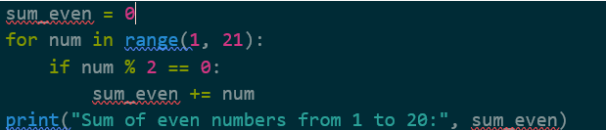

**Output:**



**Task 2:** **Find the smallest number in the list.**

num_list = [34, 12, 5, 78, 3, 90]

smallest = min(num_list)

print("Smallest number in the list:", smallest)

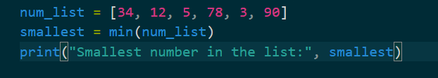

**Output:**

**Task 3:** **Extend the first list with elements from the second list.**

list1 = [1, 2, 3]

list2 = [4, 5, 6]

list1.extend(list2)

print("Extended list:", list1)

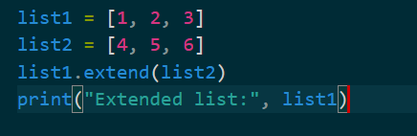

**Output:**



**Task 4:** **Write a Python program that takes a non-negative integer as input and calculates its factorial using a while loop.**

def factorial(n):

if n < 0:

return "Invalid input: Factorial is not defined for negative numbers"

result = 1

while n > 1:

result *= n

n -= 1

return result

num = int(input("Enter a non-negative integer: "))

print("Factorial:", factorial(num))

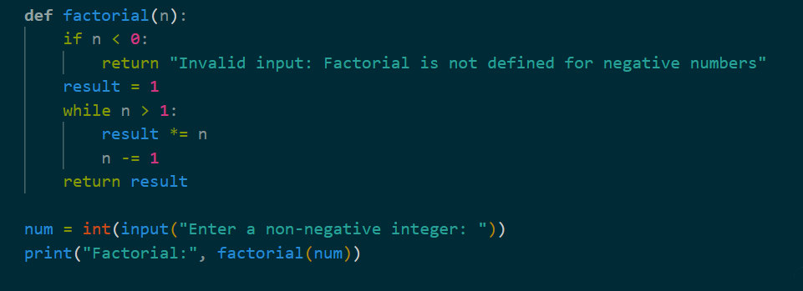

**Output:**



**Task 5:** **Check which letter is vowel or which is not. In else condition print “Consonant”?**

letter = input("Enter a letter: ")

if letter in 'aeiouAEIOU':

print("Vowel")

else:

print("Consonant")

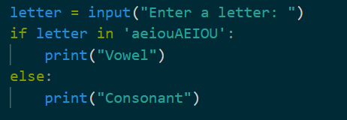

**Output:**

